Installation procedure   
Method-1 🡪 with java jdk 8  
Method-2 🡪 open jfs

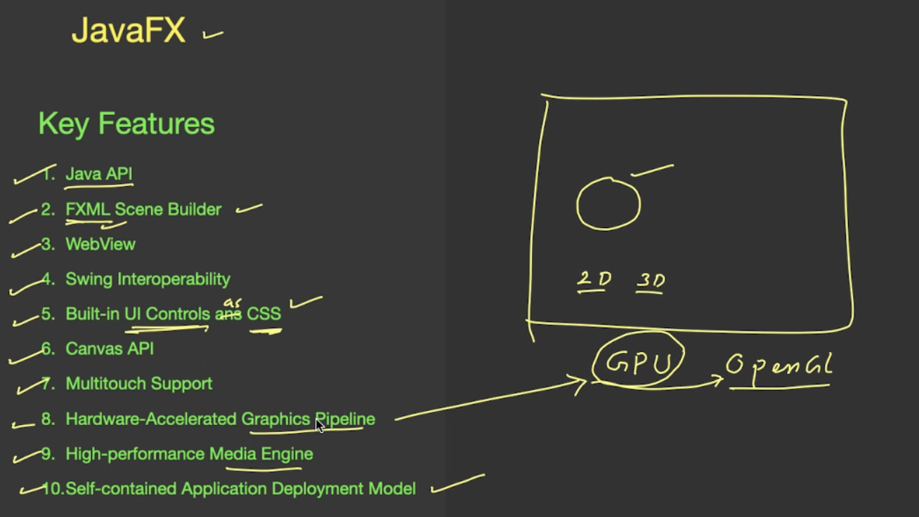

Java JFS Program structure   
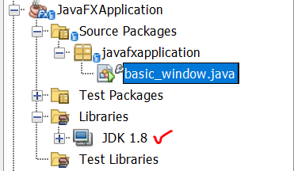

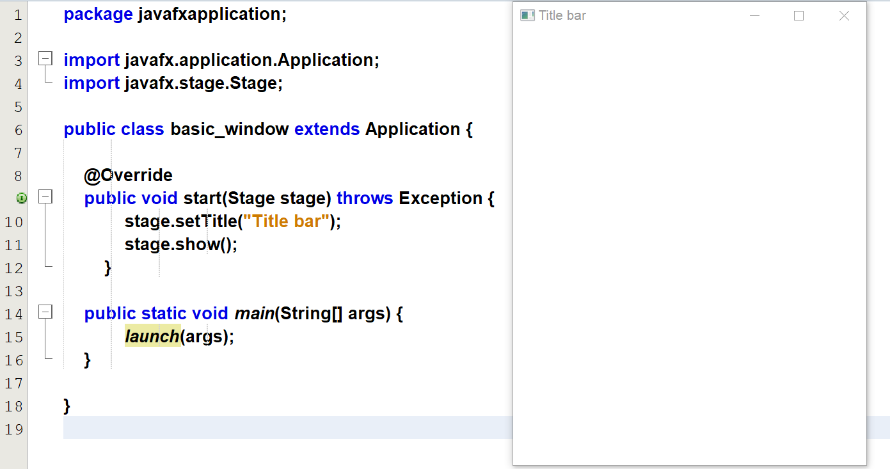

A stage can contains different scenes at different time.  
Scene will contain collections of graph called scene graph.

# **Structure of Java FX application**

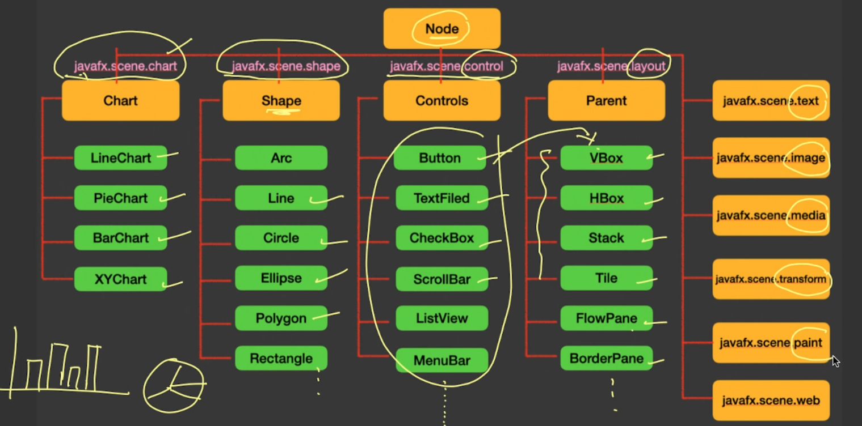

# **Structure of Java FX application**

